Splendors of South Africa & Victoria Falls with
Chobe National Park
September 8 - September 22, 2018
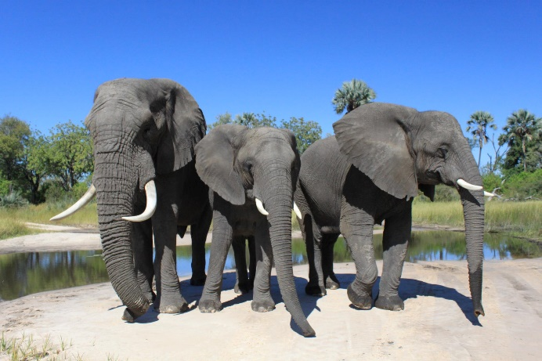

September 8 Depart uS on INternational Flight To Capetown

September 9 ARRIVE IN CAPE TOWN, SOUTH AFRICA
Welcome to South Africa! Check in to your hotel and prepare for a fascinating journey.

September 10 CAPE TOWN
This morning, sightseeing starts at the Grand Parade, the city’s main public square, to see the Castle of Good Hope and City Hall. Afterward, a WALKING TOUR introduces you to more of Cape Town’s famous and historic landmarks. Stroll along Government Avenue to see St. George’s Cathedral, Parliament, and much more. Next, you’ll enter The Company’s Garden, a beautiful oasis in the city, en route to Green Market Square, which at different times has been a fruit and vegetable market and even a slave market. Today, it is a great meeting place, where curios from all over Africa can be found. Visit the BO-KAAP MUSEUM before continuing your walk in BO-KAAP, also known as the Malay Quarter. Founded by former slaves in the 1750s, this lively area is a true melting pot of cultures. Colorful historic houses range from lime-green and pink to orange, reflecting Dutch and British architecture, and the area has been declared a national monument. After a traditional Malay lunch, visit Table Mountain for a CABLE-CAR RIDE to the top (weather permitting) for stunning views of the city and its surroundings. This evening, join your traveling companions for a welcome dinner at a local restaurant. ( B,L,D )
September 11 CAPE TOWN. CAPE PENINSULA EXCURSION
Today, enjoy a full day of sightseeing, starting with an orientation tour of Cape Town. Then, take a scenic drive south through the fishing village of Hout Bay before ascending Chapman’s Peak Drive, which skirts the rocky coastline and is one of the most scenic drives in the world. Continue on to CAPE POINT NATURE RESERVE for stops at the Cape of Good Hope and Cape Point, the southwestern most point on the African continent. Here, take a FUNICULAR RIDE to the steps of the old lighthouse for spectacular panoramic views. Afterward, visit Boulders Beach to see a COLONY OF ENDANGERED AFRICAN PENGUINS, known for the unique sound they make. Return to Cape Town and enjoy the evening at your leisure. ( B,L )
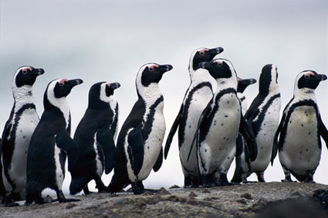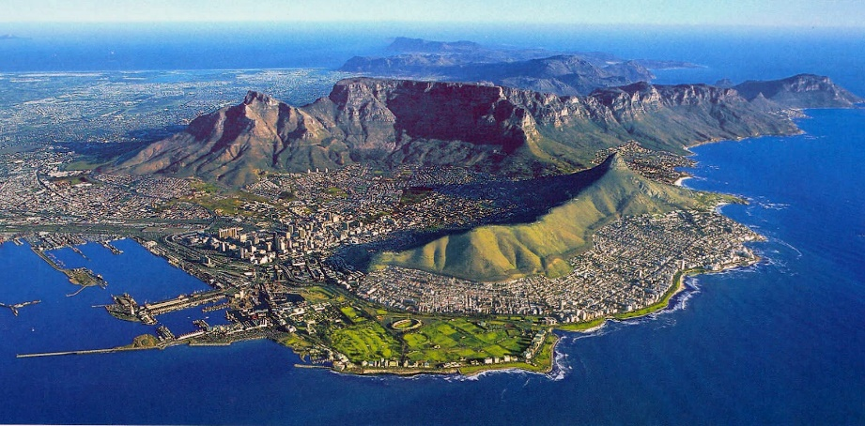

September 12 CAPE TOWN
Enjoy a full day at leisure for your own discoveries. Perhaps explore the Victoria & Alfred Waterfront, take an excursion to the stunning Cape winelands for wine tasting, or cruise to Robben Island, where Nelson Mandela spent 18 of his 27 years in prison, for a guided tour. Your Tour Director has suggestions to help you make the most of your day. ( B )

September 13 CAPE TOWN–KAPAMA PRIVATE GAME RESERVE
Today, leave beautiful Cape Town behind and fly to KAPAMA PRIVATE GAME RESERVE to begin your safari adventure! This area, near Kruger National Park, is famous for its abundance of wildlife, and you will have a great chance of seeing the “Big 5”—lion, leopard, elephant, rhino, and Cape buffalo. Enjoy your first GAME DRIVE this afternoon. Your skilled tracker and professional Ranger work together as a team, so you can learn more about the ecosystem as you view wildlife up close. Sip SUNDOWNER DRINKS prior to returning to your lodge for dinner.(B,D)

September 14 & 15 KAPAMA PRIVATE GAME RESERVE
Rise between 5 am and 5:30 am for coffee and tea before your EARLY MORNING GAME DRIVE. If the timing is right, you might spot some of the big cats after a night of hunting. Other animals you may see include kudu, impala, giraffe, hippo, cheetah, spotted hyena, wildebeest, and more. Great bird watching is also possible—some 350 species having been recorded in the area. Return for breakfast mid-morning, followed by time to relax and enjoy the lodge and its surroundings. Perhaps take a swim in the pool, visit the wellness center for one of its many spa treatments, or simply sit back and watch the animals. You may even choose to join your Ranger for a BUSH WALK to learn more about the native flora and how to identify animals by their footprints while observing them from a safe distance. Optional excursions include the nearby Hoedspruit Center for Endangered Species, where you can see a number of rehabilitated animals. In the mid-afternoon, tea will be served prior to your AFTERNOON GAME DRIVE. Step out of your safari vehicle for SUNDOWNER DRINKS and watch as the sun sets over the Drakensberg Mountains. As darkness descends, your tracker will bring out a spotlight to help you spot nocturnal animals—if you are lucky, maybe even a leopard! Return to your lodge in time to freshen up before dinner. ( B,L,D )
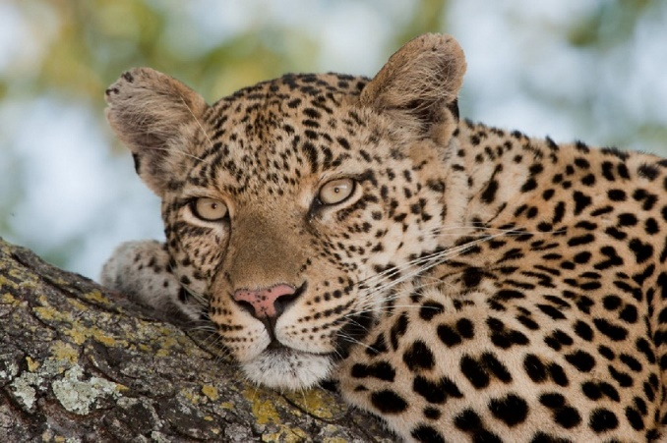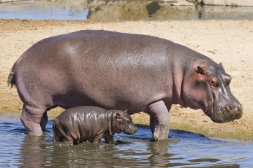
september 16 KAPAMA PRIVATE GAME RESERVE–JOHANNESBURG
Enjoy one last GAME DRIVE this morning before transferring to the airport for your flight to Johannesburg. The remainder of the day is at your leisure. ( B )

september 17 JOHANNESBURG
Today’s sightseeing starts with an enriching visit to SOWETO (South Western Township), the largest township in the country. Soweto is a part of South Africa’s turbulent past, but this multicultural area is also a reflection of today and hope for tomorrow. Along the way, see the neighborhood that was home to two Nobel Peace Prize winners: Archbishop Desmond Tutu and Nelson Mandela. Gain some perspective of life here at MANDELA HOUSE, where Nelson Mandela lived from 1946 to around 1960, when he was forced underground to elude arrest. You will also see the Hector Pieterson Memorial, dedicated to the 12-year-old boy killed by police during a demonstration in 1976. This led to the Soweto Uprising, an important event in the long struggle to end apartheid some 14 years later. Next, visit the unforgettable APARTHEID MUSEUM to learn about the founding of South Africa before delving into the apartheid era. Using photos, video, and print, the museum takes you on an extraordinary journey through the apartheid years to the 1994 democratic elections that named Nelson Mandela president. ( B,L )

september 18 JOHANNESBURG–VICTORIA FALLS, ZIMBABWE
Today, leave South Africa and fly north to Zimbabwe. This evening, enjoy a CRUISE on the Zambezi River, which affords you a great opportunity to photograph wildlife and a spectacular African sunset! ( B,D )

september 19 VICTORIA FALLS
Today, visit mighty VICTORIA FALLS for an awe-inspiring experience. Enjoy a GUIDED WALK, where you will learn the history of the falls and hear fascinating details about the surrounding flora and fauna. This evening, your Tour Director hosts a special riverside dinner.

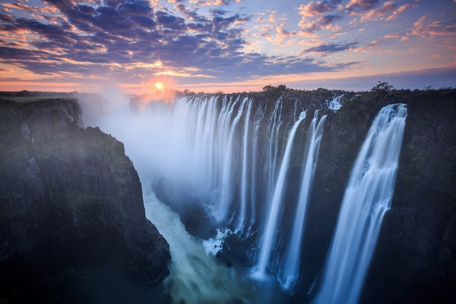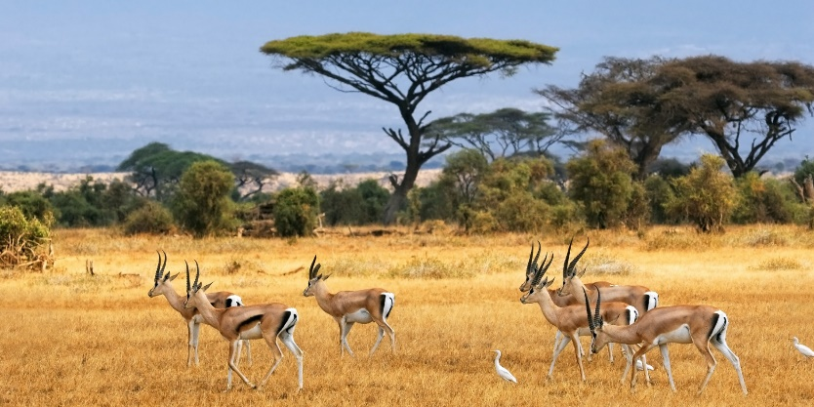

september 20 VICTORIA FALLS–CHOBE NATIONAL PARK, BOTSWANA
Today, drive to CHOBE NATIONAL PARK, home to one of the largest concentrations of game in all of Africa. After lunch, set out on your first GAME ACTIVITY, either by boat or 4-wheel-drive safari vehicle. ( B,L,D )

september 21 CHOBE
Take part in MORNING & AFTERNOON GAME ACTIVITIES today. The park is known for its huge herds of elephant, considered by some to be the largest elephants in the world. You may also see lion, leopard, cheetah, giraffe, lechwe, kudu, Cape buffalo, and much more. Birding is also very popular, with more than 450 species on record. ( B,L,D )

september 22 CHOBE–JOHANNESBURG–DEPARTURE
Your tour ends with a flight to Johannesburg to connect to your homebound flight. Book homebound flights after 5:30 pm. ( B )
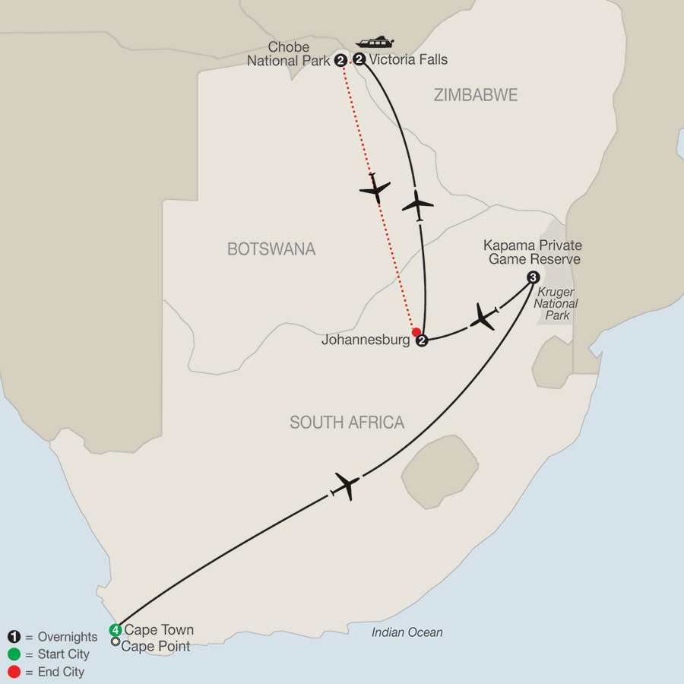

Splendors of South Africa & Victoria Falls with Chobe National Park
September 8 – 22, 2018

PRICE: $7979 (per person based on double occupancy)

Included Tour Features:

- Airfare from Minneapolis, including air within trip
- 12 nights’ accommodation
- Transportation by motor coach, open-air wheel drive safari vehicles, intra-Africa flights
- Daily breakfast, 7 lunches and 8 dinners
- 8 game drives
- All transfers
- Bottled water on all game drives
- Prepaid gratuities on the Splendors of Africa & Victoria Falls - not included on Chobe extension

If you’re traveling solo and need a single room, there is limited availability and an additional cost. Contact us for further information.

General Information
Reservations: A non-refundable deposit of $1100.00 per person is required to secure a place on our tour.

Insurance: We strongly suggest that you consider the purchase of travel insurance. Coverage includes trip cancellation for covered reasons, medical, baggage, emergency evacuation and more. Pre-existing medical conditions are covered per terms of the contract. Please ask for details. The price of insurance is $289.00 per person and must be paid at time of deposit.

Final payment: Final payment is due by June 6, 2018. We will invoice you for the balance.

Cancellation Schedule: From receipt of deposit to June 6, 2018 – Deposit plus insurance
From June 7 - August 17 – 20% of total price
From August 18 - August 31 – 30% of total price
From September 1 - September 6 – 50% of total price
From September 6 – 100% of total price

Smoking: We kindly request no smoking when and wherever the group is traveling together.

IMPORTANT: You must possess a valid U.S. passport. The passport must be valid for a minimum of 6 months from your return to the U.S. to the conclusion of the tour (March 22, 2019).

Responsibility: This tour is operated by Higgins Travel & Cruise Center. Ltd. DBA Higgins Travel Leaders at 2514 Golf Road., Eau Claire, WI 54701 Globus Voyagers, located at 5301 South Federal Circle, Littleton, CO 80123. Globus is an independent company licensed to market and distribute travel under the Globus, Cosmos, and Monograms brand names, and arrange for the vacation services offered in this brochure including transportation, sightseeing, and accommodations through independent contracts.

For More Information, Please Contact

Kurt Jacobson, 715-858-5092, kurtjacobson1313@gmail.com

Joan Lorenz, Higgins Travel Leaders 715-834-2686, joan@higginstravel.com

Registration Form
Splendors of South Africa & Victoria Falls with
Chobe National Park
September 8 – 22, 2018

1. Name______________________________________________________D.O.B._________________________ (first, middle & last legal names as they appear on passport)
Passport #____________________________________________________Exp.Date_______________________

2. Name______________________________________________________D.O.B._________________________ (first, middle & last legal names as they appear on passport)

Passport #____________________________________________________Exp.Date________________________

Address:________________________________________City:_________________________________________

State:_________________Zip:______________ Email Address:________________________________________

Cell Phone: ______________________________Home Phone:_________________________________________

United Mileage Plus Numbers: Name #1 ____________________________Name #2 _______________________

Roommate (not listed above): _______________________________

Insurance: Insurance is recommended but optional, and must be paid with your initial deposit. The insurance becomes non-refundable once paid. Information about this insurance coverage will be provided to all participants. Insurance price is $289.00 per person.

Travel Insurance:
Yes, I wish to purchase optional insurance. No, I decline cancellation insurance
Please include a photo copy of the inside photo page of each passport with your application.

Any special occasion__________________________________________________________
(For example; a birthday or anniversary while we are traveling.)

Price: $7979.00 per person based on double occupancy.

Payment: A non-refundable $1100.00 per person deposit is due to secure a place on our tour. Due to the group nature of our tour, payment must be paid by personal check. Please make checks payable to Higgins Travel and mail to 2514 Golf Road, Eau Claire, WI 54701. Final payment will be due June 6, 2018. We will send you an invoice.

In case of an emergency, please contact:
Name_________________________________________Relationship__________________

Phone or Email______________________________________________________________
Higgins Travel Leaders
2514 Golf Road Eau Claire, WI 54701

