BEST OF POLAND
April 17th- April 27, 2018
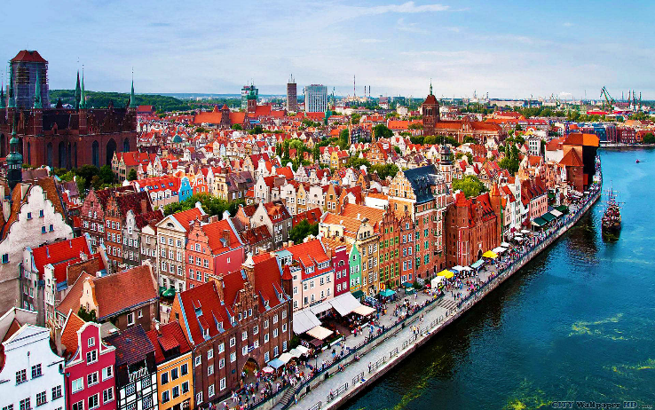
Tuesday, April 17th
We leave the US for Gdansk, Poland.

Wednesday, April 18th
We arrive at Gdansk airport where we meet David and check into our hotel. In the afternoon we’ll be given a guided tour of the beautiful port city Gdansk. Dinner and overnight Gdansk.

Thursday, April 19th
After breakfast from the buffet, we take an excursion to the Westerplatte area, the site of Hitler’s invasion of Poland, effectively setting in motion WWII. We’ll then spend time at the attractive town of Sopot nearby. The remainder of the day is ours for sightseeing, shopping and relaxing in Gdansk. Dinner and overnight Gdansk.

Friday, April 20th
After breakfast we travel on to Malbork, the impressive castle and command post of the Knights Templar. We then continue on to the lovely Masurian Lake District where we’ll be given a boat ride. Later we check into our castle hotel. Dinner and overnight Masurian Lake District.

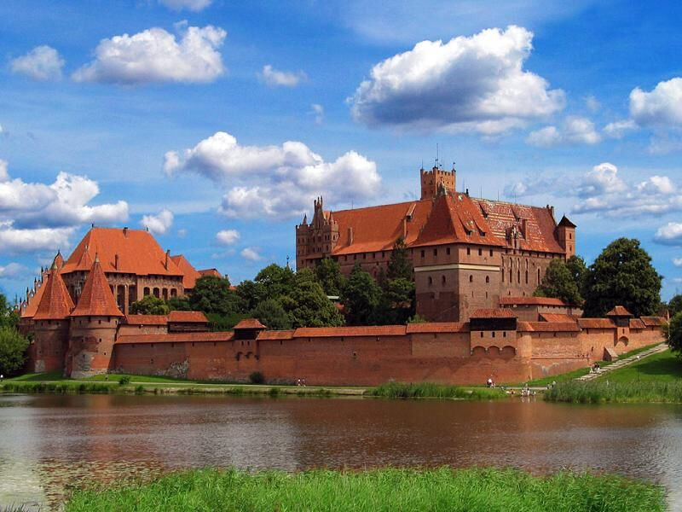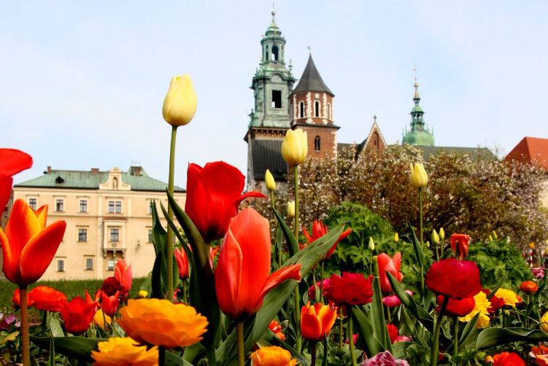

Saturday, April 21st
After breakfast we visit Adolf Hitler’s infamous “Wolf’s Lair”, the German HQs near the Russian border and site of the failed assassination attempt (as seen in the movie with Tom Cruise “Valkyrie:). We then travel on to Poland’s capital, the royal city of Warsaw. Dinner and overnight Warsaw.
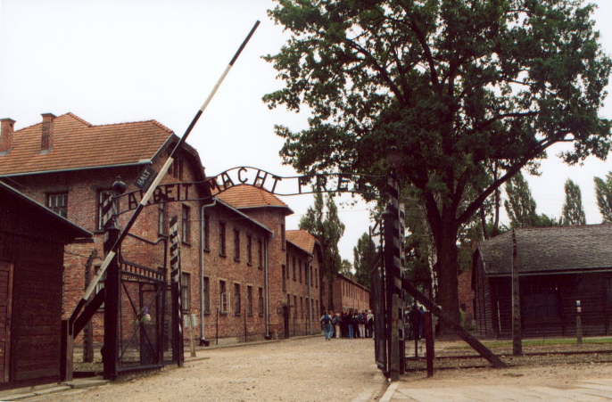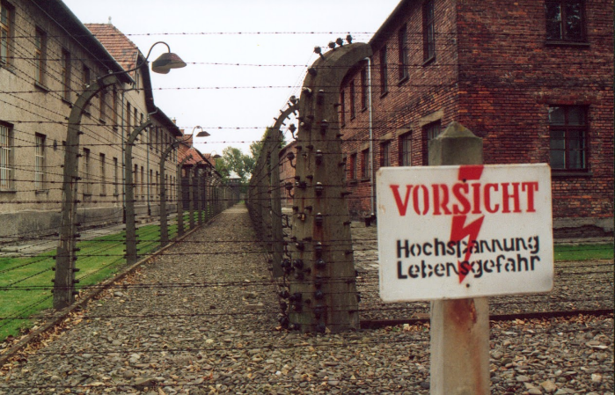
Sunday, April 22nd
After breakfast from the buffet, we spend the morning on a guided tour of Warsaw’s inimitable landmarks. The afternoon will be free to enjoy sightseeing and shopping. Dinner will be on our own tonight. Overnight Warsaw.

Monday, April 23rd
After breakfast from the buffet, we leave the hotel early to travel to Cracow, making a stop en route at the world famous Black Madonna of Czestokhowa, Poland’s premier pilgrimage site. Upon arrival in Cracow, we check into our hotel and enjoy dinner. Overnight Cracow.

Tuesday, April 24th
After breakfast from the buffet, we’ll spend the morning exploring the stunning sights of Cracow on a guided tour. After free time for lunch and shopping we meet up at 5:00 p.m. for a special tour of Szopki making traditions with an expert, after
which we have time to visit the outstanding Szopki exhibits. After the museum, we stroll over to our Pierogi-making class followed by dinner with live music and dancing. Dinner and overnight Cracow.

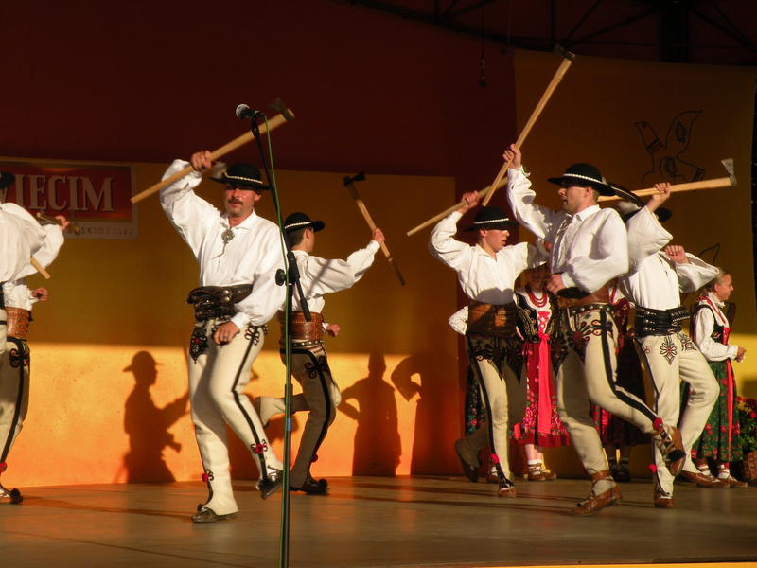

Wednesday, April 25th
After breakfast we depart for the memorable Wielizka Salt Mine Tour. The remainder of the day is free to enjoy Cracow or an optional tour to the former Auschwitz concentration camp. Dinner will be on our own tonight. Overnight Cracow.

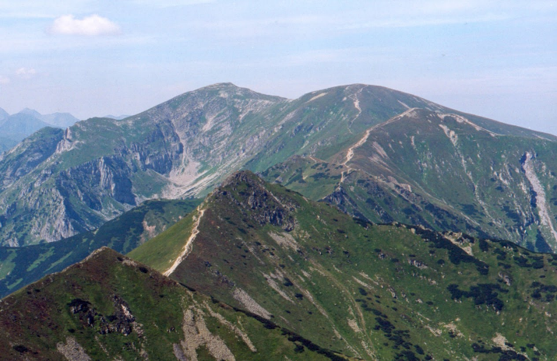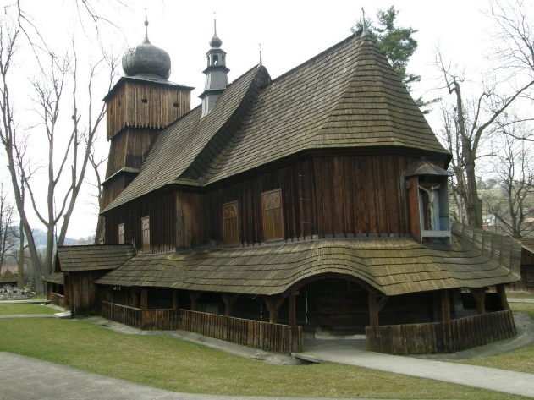

Thursday, April 26th
After breakfast from the buffet, we depart for a daytrip to Zakopane. After viewing Chocholow, a village of traditional wooden houses, we’ll take a horse-drawn carriage ride, followed by a sausage-barbecue. After visiting a wooden church and its adjoining cemetery, we have time to look around Zakopane for shopping and lunch. In the afternoon we’ll take a cable car up to get a good view of the Tatra mountains. Farewell dinner and overnight Cracow.

Friday, April 27th
After breakfast from the buffet, we check out of our hotel and transfer to the airport for our return home. Arrive same day.

The Best of Poland
April 17 – 27, 2018

PRICE: $4,099.00 (per person based on double occupancy)
Single occupancy supplement: $500.00

Our tour is based on a minimum of 20 participants. In the event this number is not reached the tour may be cancelled and all money refunded.

Included Tour Features:

- Transportation to Minneapolis Airport
- 9 nights in superior and first-class hotels
- 10 days of private coach service incl. driver, tolls, parking, fuel
- 10 days of tour manager / guide service (David)
- 9 buffet-style breakfasts
- 7 three-course dinners of regional specialties
- Admission to all paying attractions
- Local guides where applicable
- Gratuities for local guides
- Gratuities for restaurant staff at included dinners
- Luggage service at hotels
- Bed tax
- Folklore Show
- Pierogi making class
- Sausage roasting over bonfire with “Highlander tea”
- Boat ride in Masurian lake district
- Horse drawn carriage ride in Tatrzanski National Park
- Cable car ride

Not included: Beverages with dinners and Gratuities for bus driver and tour manager.
General Information
Reservations: A deposit of $300.00 per person is required to secure a place on our tour. This deposit is fully refundable until September 5, 2017.

Insurance: We strongly suggest that you consider the purchase of travel insurance. Coverage includes trip cancellation for covered occurrences, medical, baggage, emergency evacuation and more. Pre-existing medical conditions are covered per terms of the contract. Please ask for details. The price of insurance is $257.00 per person and must be paid at time of deposit.

Final payment: Final payment is due by January, 5 2018. We will invoice you for the balance.

Cancellation Schedule: From receipt of deposit to September 5, 2017 – No fee
From September 5- January 5 - $300 per person
From January 5 and later – No refund

Smoking: We kindly request no smoking when and wherever the group is traveling together.

IMPORTANT: You must possess a valid U.S. passport. The passport must be valid for a minimum of 6 months from your return to the U.S. to the conclusion of the tour (April 27, 2018).

Responsibility: This tour is operated by Higgins Travel & Cruise Center. Ltd. DBA Higgins Travel Leaders at 2514 Golf Road., Eau Claire, WI 54701 and Tailor Made Europe / David and Christine Harper, C/O 101 Churn Road, Bozeman, MT 59715. Higgins’ and Harper will act only as agent for tour members in arranging transportation, accommodations, sightseeing and admissions. We reserve the right at our sole discretion to make changes to the itinerary and are not responsible to any person for expense, loss of time or money or other circumstance that result from such a change. Rates are quoted upon tariffs and exchange rates current at time of printing and are subject to change at any time. Should the exchange rate change significantly, the price of the tour may be adjusted. Also, if fuel surcharges are imposed, the price of the tour may be adjusted. We may decline or accept any person as a tour member at any time. Higgins’ and Harper will not be responsible for any loss or damage to personal property or for injuries or damages incurred by a tour member. Higgins’ and Harper may cancel the tour, should it become necessary, and refund all monies, thus releasing Higgins Travel Leaders and Tailor Made Europe from any further obligation. We require a minimum of 20 participants to operate this tour.

For More Information, Please Contact
Mary Lemke (715)235-0429 me.lemke@yahoo.com
Higgins Travel Leaders 715-834-2686
Registration Form
The Best of Poland
April 17 – 27, 2018

1. Name______________________________________________________D.O.B._________________________ (first, middle & last legal names as they appear on passport)
Passport #____________________________________________________Exp.Date_______________________

2. Name______________________________________________________D.O.B._________________________ (first, middle & last legal names as they appear on passport)

Passport #____________________________________________________Exp.Date________________________

Address:________________________________________City:_________________________________________

State:_________________Zip:______________ Email Address:________________________________________

Cell Phone: ______________________________Home Phone:_________________________________________

Delta Sky Miles Numbers: Name #1 ____________________________Name #2 ___________________________

Roommate (not listed above): _______________________________Special requests: _____________________

Insurance: Insurance is recommended but optional, and must be paid with your initial deposit. The insurance becomes non-refundable once paid. Information about this insurance coverage will be provided to all participants. Insurance price is $257.00 per person.

Travel Insurance:
Yes, I wish to purchase optional insurance. No, I decline cancellation insurance
Please include a photo copy of the inside photo page of each passport with your application.

Any special occasion__________________________________________________________
(For example; a birthday or anniversary while we are traveling.)

Price: $4099.00 per person based on double occupancy. Single supplement: $500.00

Payment: A $300 per person deposit is due to secure a place on our tour. Due to the group nature of our tour, payment must be paid by personal check. Please make checks payable to Higgins Travel and mail to 2514 Golf Road, Eau Claire, WI 54701. Final payment will be due January 5, 2018. We will send you an invoice.

In case of an emergency, please contact: Name_________________________________________Relationship__________________

Phone or Email______________________________________________________________
Higgins Travel Leaders
2514 Golf Road Eau Claire, WI 54701

