THE PASSION PLAY TOUR 2020 and
IN THE FOOTSTEPS OF MARTIN LUTHER

HIGHLIGHTS OF GERMANY for the LUTHERAN SYNOD

Please join us on this exciting tour of Germany! We'll explore charming and intriguing historical places that are significant in the history of Music, Christianity and Lutheranism as well as other sights of great historical interest. With breathtaking alpine vistas, cultural gems such as Salzburg, Austria, reverent Oberammergau and more, this unique tour is one you will always remember.

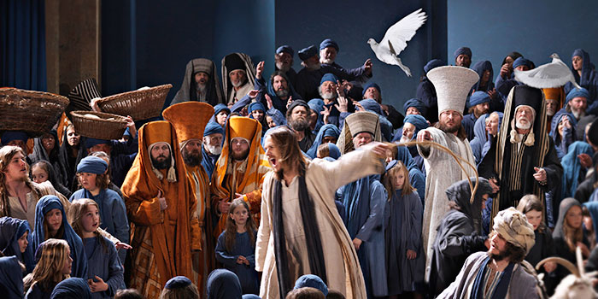
A scene from Oberammergau’s moving and dramatic Passion Play

Highlights:
The world-famous Passion Play in Oberammergau
Major “Martin Luther” sites: Eisenach, Eisleben, Wittenberg and Coburg
The “Bach House” Museum
The beautiful towns of Weimar, Nuremberg and Berchtesgaden
King Ludwig’s Fairytale castles: Neuschwanstein, Linderhof and Herrenchiemsee
Sound of Music sites in Salzburg, Mondsee and Hellbrunn
The world-famous Eagle’s Nest in Berchtesgaden
Boat trip on spectacular Lake Königssee in the National Park
Tour of the Dachau Concentration Camp Memorial Site
A visit to the BMW Museum
Great food, great atmosphere!

Airports and dates:
Fly to Frankfurt on July 8th (arrive Frankfurt airport July 9th, 2020)
Fly out of Munich on July 19th, 2020

Our bases:
2 nights near Weimar
1 night in Nuremberg
3 nights in Berchtesgaden
2 nights in or near Oberammergau
2 nights in Freising

Places and attractions:
Eisenach is not only home to the Wartburg Castle where Martin Luther translated the Bible but also to the interesting Bach House Museum dedicated to the composer. Eisleben has some historic sites connected to Martin Luther, as does the town of Wittenberg, birthplace of the Reformation.

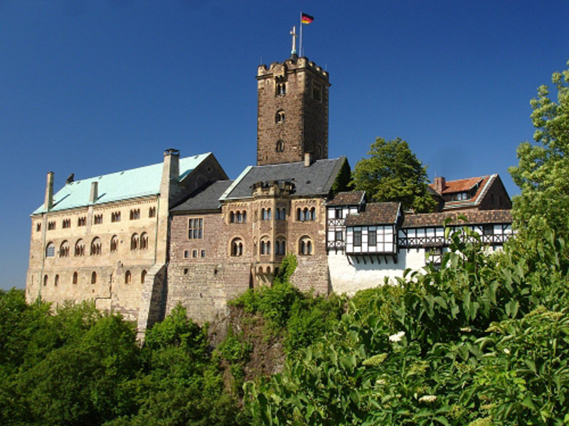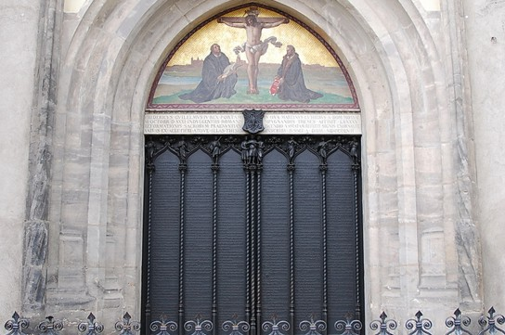
Wartburg Fortress Church door of the “95 Theses” in Wittenberg

Coburg’s fortress, the “Veste” was home to Luther for a while. The beautiful town of Nuremberg was the first to adopt the Reformation.

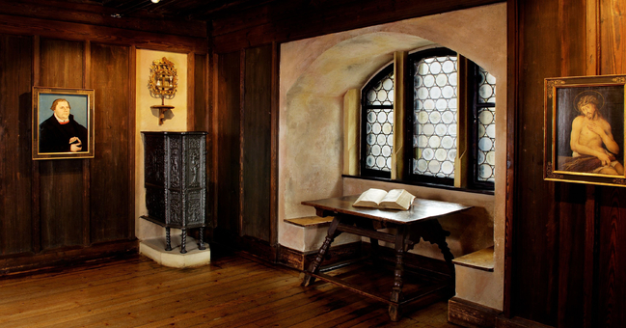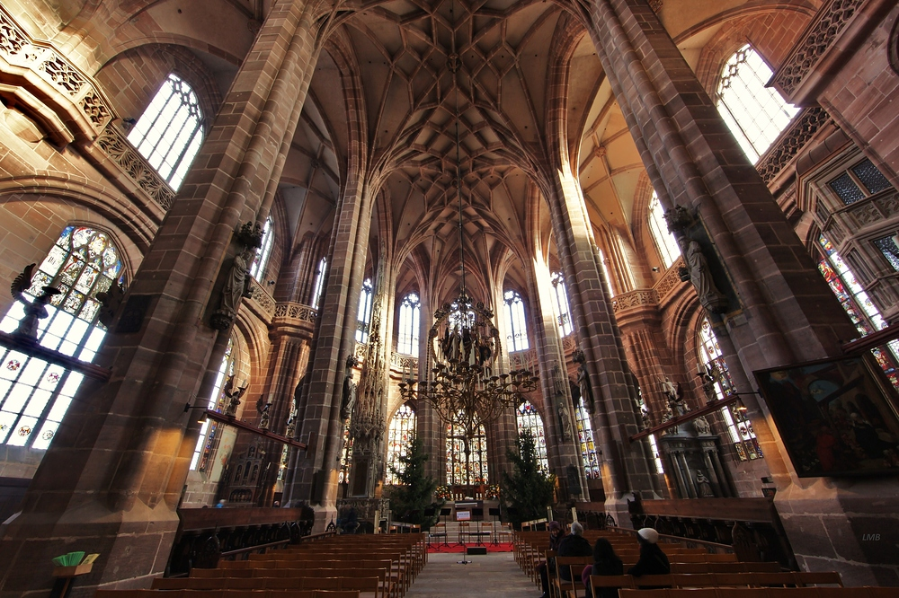
Martin Luther’s Room at Coburg’s Veste Fortress Nuremberg’s beautiful Lutheran Church

The Sound of Music wedding church is located in the colorful village of Mondsee. The city of Salzburg is rich in architectural and historic treasures. It was Mozart’s birthplace and features numerous times in The Sound of Music.
The Berchtesgaden Alps are best viewed from Lake Königssee and from the 6,000-ft-high Eagle’s Nest, once a diplomatic reception center for Hitler.
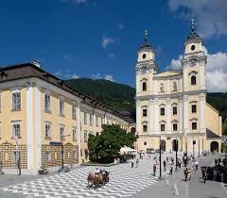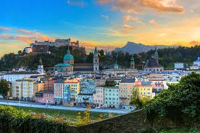
The church at Mondsee Salzburg: Mozart and the Sound of Music

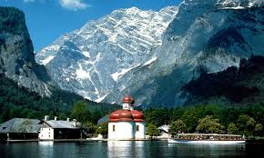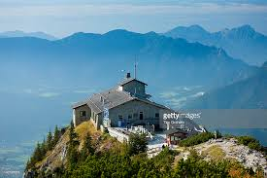

World-famous Neuschwanstein Castle was built by King Ludwig II of Bavaria. Ludwig’s two other creations, Linderhof Palace and Herrenchiemsee Palace (on an island) are equally as impressive. Oberammergau is not only home to the world-famous Passion Play that is offered every ten years, it is also Germany’s premier woodcarving town and, thanks to its painted house fronts, one of the prettiest villages in Germany.

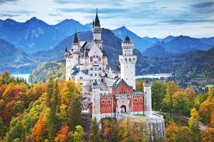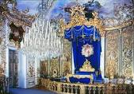
King Ludwig’s iconic Neuschwanstein King Ludwig’s bedroom at Linderhof Castle

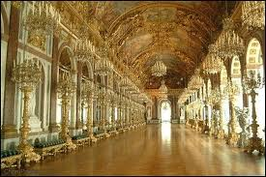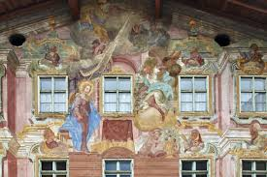
Ludwig’s Hall of Mirrors at Herrenchiemsee Oberammergau: painted façade

Itinerary:

Wednesday, July 8th, 2020 This morning we meet at the Minneapolis airport for our flight to Frankfurt, Germany.

Thursday, July 9th We arrive early to mid-morning at Frankfurt Airport. After meeting our tour manager, David Harper, we will board a private tour bus and travel to Eisenach where we visit the impressive medieval Wartburg Castle. Here we'll see the room where Luther translated the Bible. We’ll also visit the Bach House, a museum dedicated to the composer who was born in this town. We then continue to Weimar where we check into Hotel Dorotheenhof. After unpacking, we will be served a welcome dinner at the Hotel Dorotheenhof. Overnight Weimar.

Friday, July 10th After breakfast, we'll take an excursion to Eisleben, Luther's birthplace. Here we'll visit his last residence as well as St. Andrew's Church, where he preached his last sermon, and Church of St. Peter and Paul, where he was baptized. Continuing on to Wittenberg, home to Luther for some 30 years and birthplace of the Reformation, we'll visit the Luther House, Castle Church (95 Theses), St. Mary's Church (where he preached) and his tomb. This evening we'll enjoy dinner at our hotel. Overnight Weimar.

Saturday, July 11th After breakfast, we'll set off for Coburg where Martin Luther stayed for the Augsburg Imperial Diet. Here we will visit the impressive Veste Fortress where Luther spent some time writing and enjoying free time exploring Coburg’s handsome old town. We continue on to Nuremberg where we’ll have dinner and spend the night. Overnight Nuremberg.

Sunday, July 12th After an early breakfast, take a tour of the striking city of Nuremberg – the first town to accept the Reformation. Among the sights, we'll view the Lutheran church of St. Lorenz and the 3rd Reich Party Rally Grounds outside of town. Mid-afternoon we proceed to beautiful Berchtesgaden in the Bavarian Alps. Dinner and overnight at Hotel Edelweiss in Berchtesgaden.

Monday, July 13th After breakfast, we’ll head up to Obersalzberg, the site of Hitler's former retreat and headquarters. After a driving tour of the historic buildings, we’ll tour the Obersalzberg Documentation Center, as well as the underground bunker system, designed to serve the Third Reich's leaders as a fortress-like command post. Around midday we'll board a special mountain bus for a breathtaking ride up to the so-called "Eagle's Nest", a mountaintop tea-house constructed for Adolf Hitler. After the guided tour we'll have free time to enjoy the views and eat lunch. In the afternoon we’ll take a pleasant boat cruise over Lake Königssee in the heart of the Berchtesgaden National Park. We’ll then have free time for shopping at Königssee before dinner at the hotel and overnight Berchtesgaden at Hotel Edelweiss.

Tuesday, July 14th After breakfast, we'll head out to the Austrian Lake District making a stop to visit the beautiful Basilica at Mondsee, the site of the wedding scene in The Sound of Music. We head into Salzburg to discover the beauty of “Mozart's town” and its connection with the making of The Sound of Music. After plenty of free time for lunch, shopping and sightseeing on our own, we’ll stop at Hellbrunn Palace to stroll the grounds and visit the gazebo used in the movie. Upon our return to Berchtesgaden's old town center we'll be offered a glimpse of the fascinating history of Berchtesgaden, formerly an independent principality and the summer seat of the Bavarian kings. After free time in the town we'll be served dinner at our hotel. Overnight Hotel Edelweiss in Berchtesgaden.

Wednesday, July 15th After breakfast we drive to Oberammergau, making a stop en route at King Ludwig’s Herrenchiemsee Palace on the lake and at King Ludwig’s Linderhof Palace near Obrerammergau. Dinner and overnight in or near Oberammergau.

Thursday, July 16th After breakfast, we can take a stroll around Oberammergau and enjoy free time for sightseeing and shopping. Though the town's house-fronts are beautifully decorated with colorful paintings, Oberammergau is most well known for having perfected the fine art of woodcarving. This afternoon and this evening after dinner we attend the long-awaited Passion Play. Dinner and overnight in or near Oberammergau.

Friday, July 17th After breakfast, we'll depart early to visit the stunning Wieskirche, also known as “the Church in the Meadow,” on the way to touring King Ludwig’s iconic Neuschwanstein Castle. Early afternoon we continue to Hotel Zum Erdinger Weissbrau. Dinner and overnight Freising.

Saturday, July 18th After breakfast we tour the Dachau Concentration Camp Memorial Site as well as the interesting BMW museum. Dinner and overnight at Hotel Zum Erdinger Weissbrau, Freising.

Sunday, July 19th We transfer to Munich airport for the flight home.

Note: Hotels subject to change depending on availability.

Inclusions:
Roundtrip air from Minneapolis
11 days private tour coach transportation starting and ending Munich airport
11 days tour management
10 nights in superior tourist class / first class hotels
10 breakfasts from the buffet (9 breakfasts if departure flight is very early)
10 dinners of regional specialties
Welcome drink
Guiding throughout
All admission fees and special fares as per program
Good seating for the Passion Play
Luggage service
Gratuities for all included meals
Lutheran Synod Passion Play 2020 & In The Footsteps Of Martin Luther

July 8 – July 19, 2020

Tour Rate $5192.00 per person* $420.00*
Double Occupancy Single Supplement

*price can change due to airline cost and Euro/Dollar exchange rate

General Information

Reservations: A non-refundable deposit of $300 per person is due no later
than March 10, 2019. Because of the group nature of the trip, payments must
be made by check. Please make your check payable to Higgins Travel Leaders.

Payment Schedule

- Non-refundable deposit due no later than March 10, 2019 along with the optional insurance. Insurance must be purchased at time of deposit.
- Final payment is due January 8, 2020.

Cancellation Schedule

- From time of deposit until January 8, 2020 – Deposit + insurance is non-refundable
- From January 8, 2020 until July 8, 2020 – No refund

Trip Insurance

Trip insurance is optional, and the cost is 7.2% of your total price. Right now
the cost of insurance for the tour would be $374.82 for those in a double room
and $404.06 in a single room. At final payment, the insurance cost may have to
be adjusted if prices have changed.

Note: You must possess a valid US Passport for the trip and it must be valid a minimum of 6 months from your return date to the US. (January 19, 2021)

Responsibility: This tour is operated by Higgins Travel & Cruise Center. Ltd. DBA Higgins Travel Leaders at 2514 Golf Road., Eau Claire, WI 54701 and Tailor-Made Europe / David and Christine Harper, C/O 101 Churn Road, Bozeman, MT 59715. Higgins Travel Leaders and Harper will act only as agent for tour members in arranging transportation, accommodations, sightseeing and admissions. We reserve the right at our sole discretion to make changes to the itinerary and are not responsible to any person for expense, loss of time or money or other circumstance that result from such a change. Rates are quoted upon tariffs and exchange rates current at time of printing and are subject to change at any time. Should the exchange rate change significantly, the price of the tour may be adjusted. Also, if fuel surcharges are imposed, the price of the tour may be adjusted. We may decline or accept any person as a tour member at any time. Higgins Travel Leaders and Harper will not be responsible for any loss or damage to personal property or for injuries or damages incurred by a tour member. Higgins Travel Leaders and Harper may cancel the tour, should it become necessary, and refund all monies, thus releasing Higgins Travel Leaders and Tailor-Made Europe from any further obligation. We require a minimum of 28 participants to operate this tour.
Registration Form
Passion Play 2020 & In the Footsteps of Martin Luther
July 8 – 19, 2020

1. Name: _____________________________________________________ D.O.B.____________________________ (first, middle & last legal names as they appear on passport)
Passport # ___________________________________________________ Exp. Date________________________

2. Name: _____________________________________________________ D.O.B.____________________________ (first, middle & last legal names as they appear on passport)

Passport # ___________________________________________________ Exp. Date________________________

Please include a photo copy of the inside photo page of each passport with your application. (If applying new or renewing, send at a later date)

Address: ________________________________________ City: ___________________________________________

State: _________________ Zip: ______________ Email: __________ _ ___________________________

Cell Phone: ______________________________ Home Phone: ________________________________________

Delta SkyMiles Numbers: Name #1 ________________________ Name #2 ________________________

Roommate (not listed above): ____________________________ Special requests: _________________

Any special occasion__________________________________________________________
(For example; a birthday or anniversary while we are traveling.)

Price: $5192.00 per person based on double occupancy. Single supplement: $420.00
Insurance: Insurance is recommended but optional and must be paid with your initial deposit. The insurance becomes non-refundable once paid. Information about this insurance coverage will be provided to all participants. Insurance price is currently $373.82 per person in a double room and $404.06 in a single room.

Travel Insurance:
Yes, I wish to purchase optional insurance. No, I decline cancellation insurance

Payment: A $300 per person deposit is due to secure a place on our tour. Due to the group nature of our tour, payment must be paid by personal check. Please make checks payable to Higgins Travel and mail to 2514 Golf Road, Eau Claire, WI 54701. Final payment will be due January 8, 2020. We will send you an invoice.

In case of an emergency, please contact:
Name ________________________________________ Relationship ______________________________________

Phone or Email ___________________________________________________________________________________

For more information contact: Elizabeth Bartsch, Northwest Synod,
Assistant to the Bishop- 715-859-6810

