# Band of Brothers 75th Anniversary Tour

## “THE ROAD TO LIBERTY”

### From Hitler’s Eagle’s Nest to the D-Day Landing Beaches.

### October 16-28, 2019

*The journey begins with a look at post World War I Germany and Hitler’s rise to power. Obersalzberg above Berchtesgaden was Hitler’s main residence for 22 years of his life and his second seat of power after Berlin.*

*We visit the former concentration camp near Dachau, as well as the sites in Munich and Nuremberg that were used for 3rd Reich propaganda.*

*We visit an impressive Maginot Line fort at the French-German border and pay our respects at General Patton’s grave near Luxembourg.*

*We visit Bastogne where the Band of Brothers participated valiantly in the Battle of the Bulge. Passing through Reims, we visit General Eisenhower’s WWII HQs on our way to Caen in Normandy.*

*The D-Day Landing Beaches and their corresponding museums provide a dramatic finale to our educational and rewarding travels in Germany, Luxembourg, Belgium and France.*

**Wednesday, October 16th**, **2019:** We depart the US for Munich, Germany.

**Thursday, October 17th**: We arrive at Munich airport where we meet our guide / tour manager David and transfer to Berchtesgaden. Upon arrival we visit the historic old town where we can enjoy free time, or we could tour the fascinating salt mines. Dinner and overnight Hotel Grünberger, Berchtesgaden.

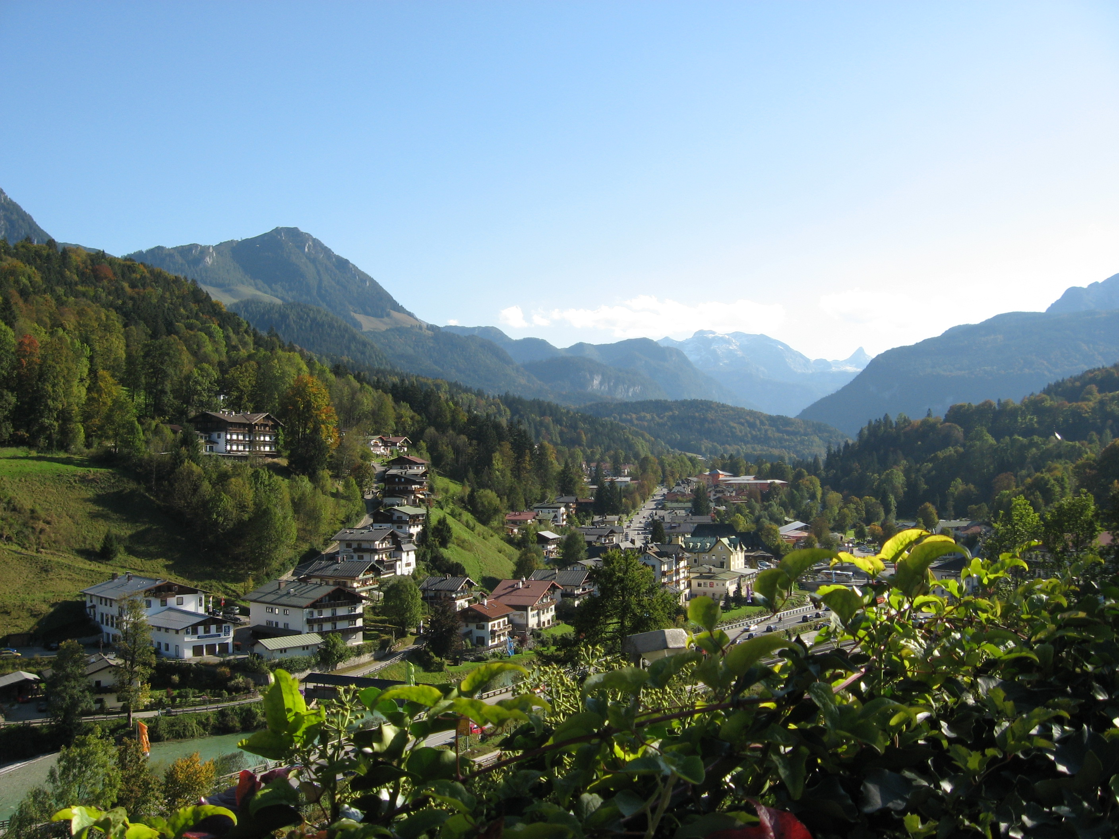

Berchtesgaden, Germany

**Friday, October 18th**: After breakfast, departure to visit the site of Hitler's alpine headquarters at Obersalzberg: underground tunnel complex, many original buildings of Hitler’s second seat of power, the 3rd Reich History Museum and, naturally, the Eagle's Nest with free time for lunch in Hitler’s dining room or on the terrace. We return to Berchtesgaden town center mid-afternoon where we can enjoy some free time in the old town. Dinner and overnight Hotel Grünberger, Berchtesgaden.



Views from the Eagles Nest

Underground tunnel complex

**Saturday, October 19th**: After breakfast we transfer to Munich early where we take a short driving tour through the city to view the buildings connected to the 3rd Reich’s presence in Munich (Koenigsplatz, Führer’s Headquarters, Haus der Kunst, etc). We then tour the Concentration Camp Memorial Site near Dachau. In the evening we check into Hotel Viktoria in Nuremberg. Dinner and overnight Nuremberg.

**Sunday, October 20th**: After breakfast we visit the former Nazi Party Rally grounds: the Luitpold field, Zeppelin tribune, SS training school and the Congress Hall building. We’ll also visit the museum attached to “Courtroom 600” where the Nuremberg Trials took place. Free time in Nuremberg’s historic town center before dinner. Overnight Nuremberg.

**Monday, October 21st**: After breakfast we travel to the town of Bitche near the French-Germany border where we take a tour of the impressive Simserhof Maginot Line fort. Dinner and overnight Bitche at the Relais des Chateaux Forts Hotel.

**Tuesday, October 22nd**: After breakfast we leave early to travel to Bastogne where we visit the sights, memorials and extensive museum connected to the Battle of the Bulge – where the Band of Brothers’ greatest trials took place. We’ll also explore the woods where the 101st were based and try to find remnants of foxholes. Dinner and overnight at La Grande Cure in Marcourt, Belgium.



Bois Jacques Woods / The Battle of the Bulge

Foxholes used by Easy Company

**Wednesday, October 23rd**: After breakfast we visit the extensive WWII museum at Diekirch in the Grand Duchy of Luxembourg as well as Hamm Cemetery near Luxembourg to pay our respects to General Patton. Late afternoon we arrive in Reims. Dinner and overnight Reims at the Novotel Suites.

**Thursday, October 24th:** After breakfast we visit Genderal Eisenhower’s WWII HQs and the cathedral of Reims before traveling to Caen in Normandy. En route we make a stop at a Calvados distillery for a tour and tasting. Dinner near our hotel in Caen. Overnight Hotel Royal Caen.

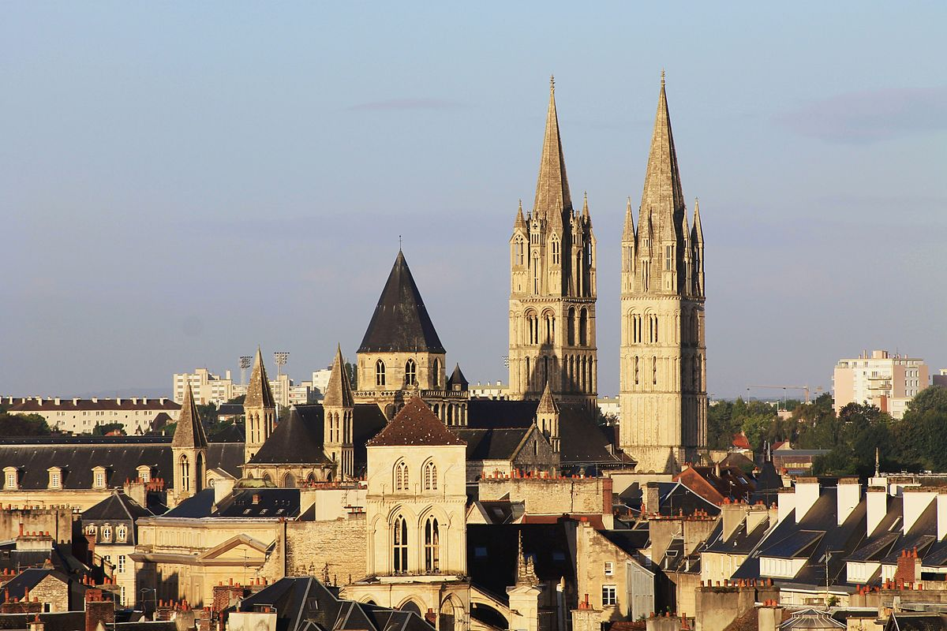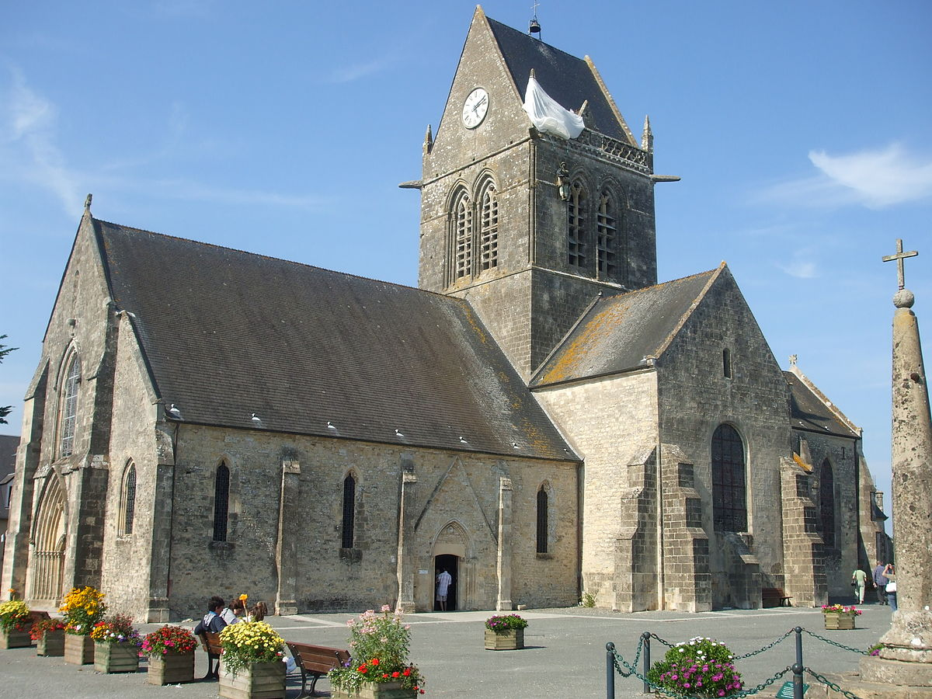**Friday, October 25th**: After breakfast, we make a full-day excursion: first to Utah Beach and the D-Day Landing Museum of Ste Marie-du-Mont, then, passing through the 101st Airborne paratroopers’ drop-zone, to the village of Ste Mère l’Eglise where we have time for lunch and visit the Airborne Museum. Late afternoon we continue to the famous Pointe du Hoc, site of a savage battle. This evening we have some time to explore the town. Dinner and overnight Caen, Normandy.

Explore the town of Caen, Normandy

Provided by Google

The Beautiful Sainte-Mère-Église

Provided by Google

**Saturday, October 26th**: After breakfast, we make a full-day excursion, first to the world-famous William the Conqueror “tapestry” in Bayeux. We then push on to Arromanches where we visit the 360-degree circular cinema above the former Mulberry Harbor. We have free time for lunch before continuing to the Normandy American Cemetery overlooking Omaha Beach, and, finally, the German defense bunkers at Longues (as seen in The Longest Day). Dinner and overnight Caen, Normandy.

**Sunday, October 27th**: After breakfast, we check out of the hotel to visit the iconic Mont Saint Michel. We push on to Paris Charles de Gaulle airport early evening. Dinner and overnight Paris airport hotel, Crowne Plaza.

**Monday, October 28th**: We transfer to our departure terminal for our flight(s) home and arrive the same day.

**The Band of Brothers, Road to Liberty Tour**

**75th Anniversary of D-Day**

**October 16-28, 2019**

**Price: $4,684.00 (per person based on double occupancy)**

Single occupancy supplement: $550.00

Our tour is based on a minimum of 20 participants. In the event this number is not reached the tour may be cancelled and all money refunded.

**Included Tour Features:**

* Transportation to Minneapolis Airport
* Roundtrip Airfare
* 11 nights in superior and first-class hotels
* 12 days of private coach service included
* 11 buffet-style breakfasts
* 10 three-course dinners of regional specialties
* Admission to all paying attractions
* Local guides where applicable
* Gratuities for local guides
* Gratuities for restaurant staff at included dinners
* Luggage service at hotels
* Bed tax

**Not Included:** Beverages with dinners and gratuities for bus driver and tour manager.

**General Information**

**Reservations:** A deposit of $300.00 per person is required to secure a place on our tour. This deposit is fully refundable to April 1, 2019.

**Insurance:** We strongly suggest that you consider the purchase of optional travel insurance. Coverage includes trip cancellation for covered occurrences, medical, baggage, emergency evacuation and more. Pre-existing medical conditions are covered per terms of contract. Please ask for details. The price of insurance is $338 for double rate and $377 for single rate.

**Final payment:** Final payment is due by July 12, 2019. We will invoice you for the balance.

**Cancellation Schedule**: From receipt of deposit to April 1, 2019 – No fee

From April 19-July 12 - $300 per person

From July 13 & later – No refund

**Smoking:** We kindly request no smoking when and wherever the group is traveling together.

**Important:** You must possess a valid U.S. Passport. The passport must be valid for a minimum of six months from your return to the U.S. at the end of the tour (October 28, 2019)

**Responsibility:** This tour is operated by Higgins Travel & Cruise Center. Ltd. DBA Higgins Travel Leaders at 2514 Golf Road., Eau Claire, WI 54701 and Tailor Made Europe, 101 Churn Road, Bozeman, MT 59715. Travel Designs, Higgins’ and Tailor Made Europe will act only as agent for tour members in arranging transportation, accommodations, sightseeing and admissions. We reserve the right at our sole discretion to make changes to the itinerary and are not responsible to any person for expense, loss of time or money or other circumstance that result from such a change. Rates are quoted upon tariffs and exchange rates current at time of printing and are subject to change at any time. Should the exchange rate change significantly, the price of the tour may be adjusted. Also, if fuel surcharges are imposed, the price of the tour may be adjusted. We may decline or accept any person as a tour member at any time. Travel Designs, LLC, Higgins’ and Tailor Made Europe will not be responsible for any loss or damage to personal property or for injuries or damages incurred by a tour member. Travel Designs, LLC, Higgins’ and Tailor Made Europe may cancel the tour, should it become necessary, and refund all monies, thus releasing Travel Designs, LLC, Higgins Travel Leaders and Tailor Made Europe from any further obligation. **We require a minimum of 20 participants to operate this tour.**

## Registration Form

# Band of Brothers 75th Anniversary Tour

## October 16-28, 2019

1. Name: _____________________________________________________ D.O.B.____________________________ (first, middle & last legal names as they appear on passport)

Passport # ___________________________________________________ Exp. Date________________________

2. Name: _____________________________________________________ D.O.B.____________________________ (first, middle & last legal names as they appear on passport)

Passport # ___________________________________________________ Exp. Date________________________

**Please include a photo copy of the inside photo page of each passport with your application. (If applying new or renewing, send later)**

Address: ________________________________________ City: ___________________________________________

State: _________________ Zip: ______________ Email: __________ _ ___________________________

Cell Phone: ______________________________ Home Phone: ________________________________________

Delta SkyMiles Numbers: Name #1 ________________________ Name #2 ________________________

Roommate (not listed above): ____________________________ Special requests: _________________

**Any special occasion__________________________________________________________**

(For example; a birthday or anniversary while we are traveling.)

**Price:** $4684.00 per person based on double occupancy. **Single supplement:** $550.00

Travel Insurance (must be purchased at the time of deposit): $338 based on double occupancy. $377 for single occupancy.

Yes, I wish to purchase optional insurance. No, I decline cancellation insurance

**Payment:** A $300 per person deposit plus insurance is due to secure a place on our tour. **Due to the group nature of our tour, payment must be paid by personal check**. Please make checks payable to Higgins Travel and mail to 2514 Golf Road, Eau Claire, WI 54701. Final payment will be due July 12, 2019. We will send you an invoice.

**In case of an emergency, please contact**:

Name ________________________________________ Relationship ______________________________________

Phone or Email ___________________________________________________________________________________

**Higgins Travel Leaders**

**2514 Golf Road Eau Claire, WI 54703**

**715-834-2686**